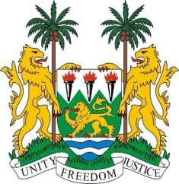
SIERRA LEONE
24th Session of the UPR

SOLOMON ISLANDS

25 January 2016

Mr President,

Sierra Leone warmly welcomes the delegation of the Solomon Islands and thanks them for their national report.

My delegation commends the Government on the significant strides it has taken in the promotion of human rights since their last review cycle in 2011, including Family Protection Act of 2014.

It is noteworthy that the Solomon Islands established a UPR National Working Committee and has implemented a series of policies criminalising the trafficking in persons.

As a Small Island Developing State it is understandable that many challenges faced by Solomon Islands have impeded its capacity to fully implement the needed changes to its laws and customs which would bring it in line with international norms, and my delegation would in this regard encourage the Solomon Islands to continue to work with regional and international partners to seek a viable solution.

Sierra Leone would like to encourage the Solomon Islands to develop strategies and policies which are aimed at cohesively promoting equality between the genders and which ensure the non-discrimination against women. In a similar vein, my delegation would encourage the government to expedite the enactment of the child and welfare bill.

Sierra Leone would like to make the following recommendations:

- Ratify the core human rights instruments including the ICPPED, CAT and ICRMW.
- Reform of the Penal Code with a provision encompassing the definition and criminalisation of all forms of sexual violence rape.
- Seek the required technical assistance in order to meet its various human rights obligations.
- Submit its overdue reports to the relevant treaty bodies.

To conclude, Sierra Leone wishes the Solomon Islands every successful in completing this review cycle.

Thank you, Mr President.

